*Name=Aditya Anal*

Profile=data enginner

**Hadoop commands tutorials**

Hdps: HDFS is the primary or major component of the Hadoop ecosystem which is responsible for storing large data sets of structured or unstructured data across various nodes and thereby maintaining the metadata in the form of log files.

**1.Jps command:** To check the Hadoop services are up and running use.

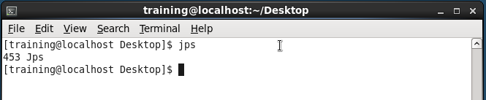

**2.ls:** This command is used to list all the files.

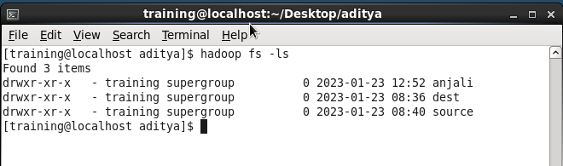

**3.mkdir**: To create a directory.

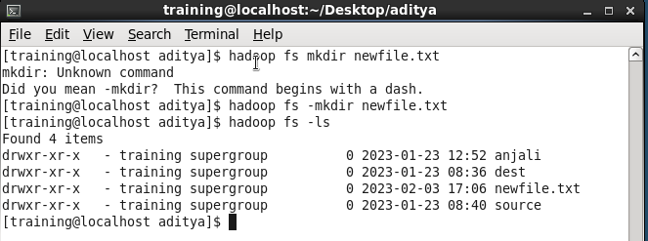

**4.touchz**: It creates an empty file.

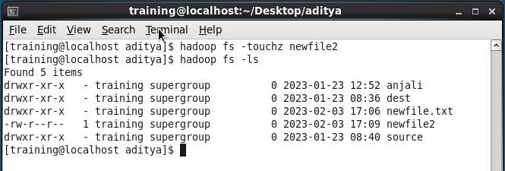

**5.rmr:** This command deletes a file from HDFS recursively.

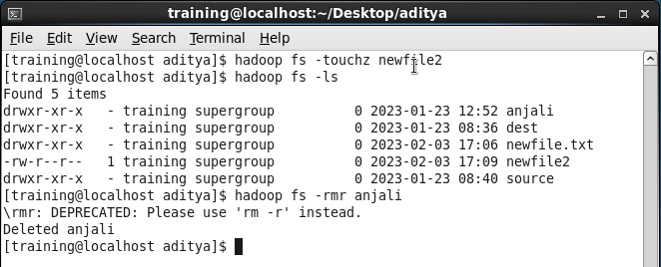

**6.copyFromLocal (or) put:** To copy files/folders from local file system to hdfs store.

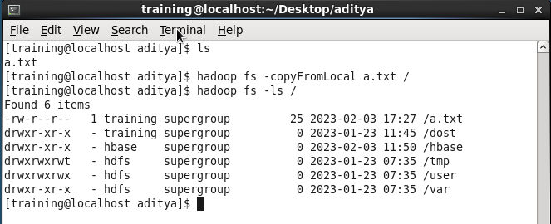

**7.copyToLocal (or) get:** To copy files/folders from hdfs store to local file system.

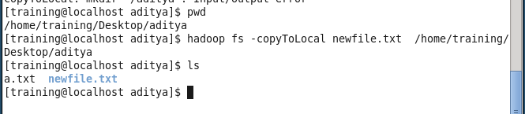

**8.moveFromLocal:** This command will move file from local to hdfs.

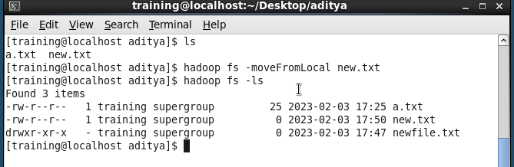

**9.du:** It will give the size of each file in directory.

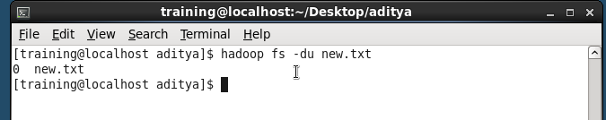

**10.dus:**: This command will give the total size of directory/file.

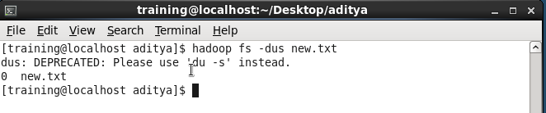

**11.cp:**This command is used to copy files within hdfs.

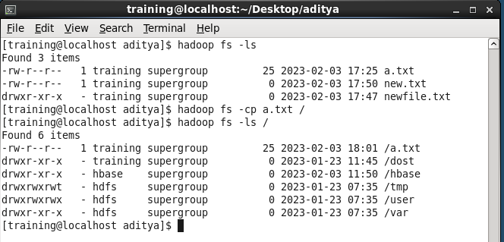

**12.mv:** This command is used to move files within hdfs.

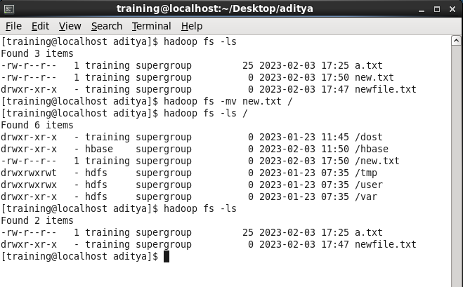

**13.stat:** It will give the last modified time of directory or path.

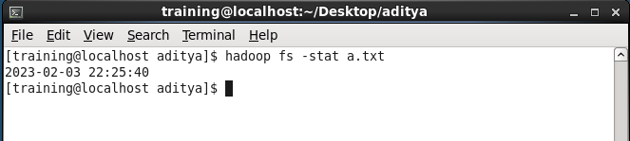

**14.hadoop fs:** Give the list of all commands.

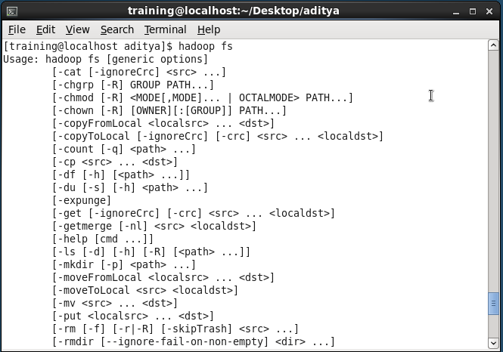

**15.cat:** To print file contents.

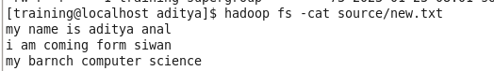

**16.getmerge:**to merge the two file in new file.

